Anglia Ruskin University

Your Project Title Goes Here

Student ID:

Module: Research Methods for Business and Management

Assessment: 011 Research Proposal

Code: MOD001105

Faculty: Lord Ashcroft International Business School

Lecturer: Andre Samuel

Date: xx May 2019

Table of Contents
Chapter 1 Introduction 3
1.1 Introduction 3
1.2 Research Issue 3
1.3 Rationale 3
1.4 Research Question 3
1.5 Research Aim 3
1.6 Research Objectives 4
Chapter 2 Literature Review 5
2.1 Introduction 5
2.2 Body 5
2.3 Summary 5
Chapter 3 Research Design and Methodology 6
3.0 Introduction 6
3.1 Research Paradigm 6
3.1.1 Research Philosophy 6
3.1.2 Research Approach 6
3.1.3 Research Strategy 6
3.2 Research Design 6
3.3 Data Collection 7
3.3.1 Questionnaire 7
3.3.2 Interviews 7
3.3.3 Summary of Data Collection 7
3.4 Data Analysis Plan 7
3.4.1 Quantitative Analysis 7
3.4.2 Qualitative Analysis 8
3.5 Ethics 8
3.6 Limitations to Research Methodology 8
3.7 Research Timetable 9
3.8 Conclusion 9
Reference List 10

Chapter 1 Introduction

Introduction
Should provide the background to your study
Define your topic area
Introduce the Issue
Indicate of the theoretical perspective you intend to bring to your study i.e. Underlying Theory
Outline the main RATIONALE for the research. What could this research shed light on?

Research Issue
Why is it an issue now, today?
Discuss the main issue or problem under research
Discuss symptoms of the issue
Give examples of empirical evidence to illustrate your issue (research data, from secondary sources)
Use academic literature as well to support your claim of the issue

Rationale
Should give reason as to why this problem should be understood and solved
Must provide evidence of the rewards of solving this problem to the industry, sector or organization
Could say how the research outcome will be of value in solving the problem
Use theory to provide the strategic benefits and to support your research idea, that it can indeed solve the problem
What is your contribution to knowledge?
What implications will the research have for practice? How will it improve or change current practice?

Research Question
State the RQ in BOLD
Make sure to discuss the research question
Justify the research question by saying that this would involve doing exploration, explanatory etc research
Discuss the focus of your research
Remember that your problem definition would have clearly lead you to the RQ

Research Aim
One aim is all we need
The aim should be the end product of the entire research
i.e. the major outcome of the tedious research process
the aim is an expression of the answer to your RQ

Research Objectives
3 to 4 objectives is sufficient
The objective should represent milestones in your research project
It should build up to the aim at the end
It should be documentable in your report
Remember that project tasks are not objectives
Think of the things that you would have to do in order to answer your RQ or achieve your Aim
Progressive, Action, Outcome, Evidence

Chapter 2 Literature Review

Introduction
Start strong by bring relevance to the topic area, outline the key aspect or concepts of the topic area that will be reviewed.

Body
Please rename the above heading to an area relevant to the topic under research
Add you sub headings accordingly 2.2.1 etc for the Body

Summary
This is where you sum up the debate of the review above. What are the key points and concepts?
Present the Conceptual Framework (diagram of key concepts and their relationships)

Chapter 3 Research Design and Methodology

3.0 Introduction
Define Research Design. Use either the Honeycomb Model (Wilson 2016) to outline the typical contents of the chapter.
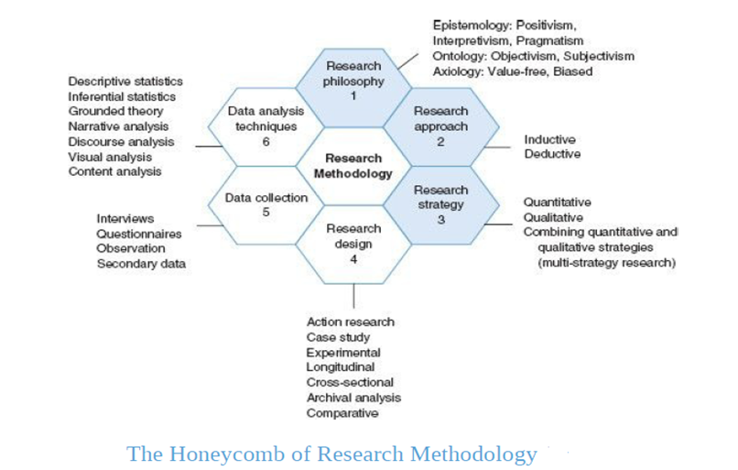

3.1 Research Paradigm (see pg. 36-50 Wilson text)
Define Research Paradigm- make sure to say that it is influenced by key philosophical assumptions.

3.1.1 Research Philosophy
Start with a discussion of Epistemology- Knowledge and Knowing
Decide on whether you are using a Phenomenological OR Positivistic paradigm OR Pragmatism
Move on to the idea of Ontology- Reality
Discuss whether your research will be based on an Objective or Subjective stance.
Justify your choices by using literature and apply to your research context.
It might be useful to say why the other cannot work or why it might not be applicable

3.1.2 Research Approach
Define both Inductive and Deductive Approaches
Must discuss whether you are using Inductive or Deductive role of theory
It is important that you justify your choice given the context of your research
It might be useful to say why the other cannot work or why it might not be applicable

3.1.3 Research Strategy
Define Quantitative, Qualitative and Mixed Methods
You must then relate that to whether you are following a Quantitative or Qualitative approach or Mixed Methods
Justify your choices by using literature and apply to your research context.
It might be useful to say why the other cannot work or why it might not be applicable

3.2 Research Design (see pg. 172 Wilson Text)
Must outline the strategy chosen ONE; action research, survey, ethnography, case study etc.
Should justify your choice, again use theory and apply to your research context.
Explain how the methodology would be rolled out i.e. your idea for action:
Full details needed here (What, HOW, Why)
Not good enough to only state choice
Must give the time horizon of your research, either Longitudinal or Cross Sectional

3.3 Data Collection (see pg. 219 Wilson text)
Give a brief introduction into your data collection; both primary and secondary data will be collected in order to achieve the research objectives.

3.3.1 Questionnaire
Which objective will be achieved through the questionnaire?
Discuss clearly and in detail: Purpose of questionnaire, Specify Who, sampling technique to be used, calculated sample size, distribution and collection method, variables to be measured, how will they be measured e.g. 5 point Likert Scale.

3.3.2 Interviews
Which objective will be achieved through the interview?
Discuss clearly and in detail: Purpose of interview, Specify Who, what themes will be used to ask questions, type of interview (semi-structured), Mode of Interview (face to face), Interview preparation, Recording the interview

3.3.3 Secondary Data (see pg. 264 Wilson text)
Define secondary data, outline sources of secondary data.
Discuss the specific documents that you are using to compile your research findings. E.g. a case study, published research data etc.

Create a table to list the documents you are using:
Title of Document | Source | Date of Publication
EMPLOYEE JOB  SATISFACTION AND  ENGAGEMENT: THE DOORS  OF OPPORTUNITY ARE OPEN | Shrm.org | 2018

You can add more or change heading accordingly

3.3.4 Summary of Data Collection
Use the table below to summarize your data collection methods usage
Objective | Who/Where?  Source | Data Needed Themes/Constructs | How will the Data be collected?  Method

3.4 Data Analysis Plan
Introduction to the types of data that will be collected. So questionnaires will give Quantitative data, Interviews will give Qualitative Data. Therefore, the research will require both types data analysis.

3.4.1 Quantitative Analysis (see pg. 318 Wilson text)
Outline process of transforming the raw data i.e. sorting, coding, data entry
Discuss the use of:
- Descriptive Statistics- Tables, Distribution Frequencies, Cross Tabulation, Central Tendency (Mean, Median, Mode), Scatter Diagrams, Graphical Forms (Pie, Bar etc)
2. Inferential Statistics- Forecasting, Time Series, Pearson’s Coefficient, Spearman’s Rank Coefficient, Chi Squared and Student t-test

3.4.2 Qualitative Analysis (see pg. 378 Wilson text)
Discuss the use of Thematic Analysis which is rooted in Narrative Analysis.
Use Creswell (2009) model:
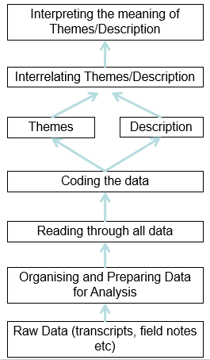
Discuss process of transforming the raw data i.e. transcription, reading, making notes, categorizing into themes, describing the themes, interrelating the themes.
See session 8 slide 6, RM handout 2 pg. 159

3.5 Ethics (see pg. 139 Wilson text)
Define Ethics in Research
Outline the likely ethical issues you will encounter
You must then outline your tactics to mitigate the ethical risks
Summarise using a table. See Lecture on Ethics for Stages and Risks
Stage of the research | Ethical Risks | Mitigation

3.6 Limitations to Research Methodology
Every methodology would have some margin of unknown or area of uncertainty
You may also be working at this stage on many assumptions
You need to state these
Issues that might affect the quality of the research
What obstacles you may encounter e.g. response rates, access to interviewees

3.7 Research Timetable
Include a short explanation of, your proposed dissertation structure.

Also include a Plan Narration justifying the timelines proposed for your research and outline key dates e.g. start of data collection, completion of analysis.
Include Gantt Chart here.

3.8 Conclusion
Provide a conclusion summing up your entire proposal.
Iterate the main points from:
- Chapter 1- issue, aim of the research
- Chapter 2- main body of literature, underlying theory
- Chapter 3- chosen philosophy, approach and strategy, design and data collection methods.

Reference List

All sources cited in the body in alphabetical order, in compliance with Harvard Reference Style.
https://libweb.anglia.ac.uk/referencing/harvard.htm

