**Mark scheme for Project Proposal (80%)**

You are required to write a research proposal on a topic of your choice. It is advisable that this

should match your final dissertation. You should format your report around the following key aspects:

1 Provide a suitable title for your work and briefly describe the hypothesis that you intend to demonstrate, prove or test. **(10 marks)**

2 Explain, backed up by the relevant academic literature, why you propose to carry out research on the chosen topic. This should involve a review of the relevant literature and the current practice to put your project in context and establish a justification for this work. **(20 marks)**

3 Describe your research methodology and approach. Back up your decision with suitable references supporting methodological and design process.

**(10 marks)**

4 Describe the key technical aspects of your project, outlining the experimental procedures, design of any software, data collection processes and tools to analyse data. **(10 marks)**

5 Include a Gantt Chart of the proposed activities required to successfully complete the proposed research within the time framework. This must be accompanied with brief descriptive text to provide details for your key milestones and deliverables. **(10 marks)**

6 You should make it clear whether your proposed research will require ethics approval. Include the ethics checklist and online ethics-training certificate in your list of appendices. **(10 marks**)

7 Provide a report format with contents list, numbered headings and sub-headings and correct use of Harvard style references. **(10 marks)**



**Research Methods (MOD002695)**

<<Research Title>>

**Faculty: Science and Engineering**

**School: School of Computing and Information Science**

**Partner Institution: SAM Trinidad**

**Academic Year: 2020/2021 Tri 2**

**Table of Contents**

1.Introduction 3

2. Literature Review and Conceptual Framework 3

3. Research Methodology and Approach 4

4. Data Collection Tools 4

5. Project Plan 4

6. Ethics Checklist 5

7. References 5

# 1. Introduction- 700 words

Define topic and general background

* 1. Issue and Rationale

Empirical Evidence of the issue, literature supporting the issue.

(3 paragraphs)

* 1. Research Question
  2. Research Aim
  3. Research Objectives

# 2. Literature Review and Conceptual Framework- 800 words



Introduce what will be reviewed in the chapter.

Use your research objectives to identify the key topics for review.

Use headings to reflect topics as below

Write up critical review of journal articles etc relative to each

2.1 Objective 1- use key words as headings

2.2 Objective 2-



2.3 Objective 3

2.4 Conceptual Framework

# 

# 3. Research Methodology and Approach- 700 words

Introduction- define research methodology, use the honeycomb model (Wilson)

3.1 Research Philosophy-

discuss Epistemology (interpretivism, positivism, pragmatism, chose one)

discuss Ontology- (subjectivism, objectivism, chose one)

3.2 Research Approach-

Discuss inductive and deductive (chose one)

3.3 Research Strategy-

Discuss qualitative, quantitative, mixed methods (chose one)

3.4 Research Design- state your choice, explain what, how and why.



# 4. Data Collection Tools- 700 words

4.1 Data Collection Procedure





4.2 Data Analysis Plan

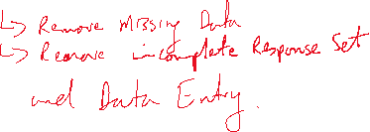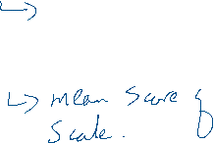

# 5. Project Plan



The project plan is based on the work required to complete the research and the documentation of the five chapters. See below for document outline.



|  |  |
| --- | --- |
| Chapters | Outline |
| 1. Introduction | Review of the research issue and scope, research aim, objectives and Research question |
| 1. Literature Review |  |
| 1. Research Design and Methodology |  |
| 1. Findings and Analysis |  |
| 1. Conclusions and Recommendations |  |

The project is expected to start on 2nd June 2021, with completion for Jan 7th 2022, resulting in a total project duration of 155 days approx. There are several milestones throughout the project, which will act as checkpoints for progress. See table below for milestone plan.



Firstly, the researcher will apply for ethics application…………….PLAN Narrative

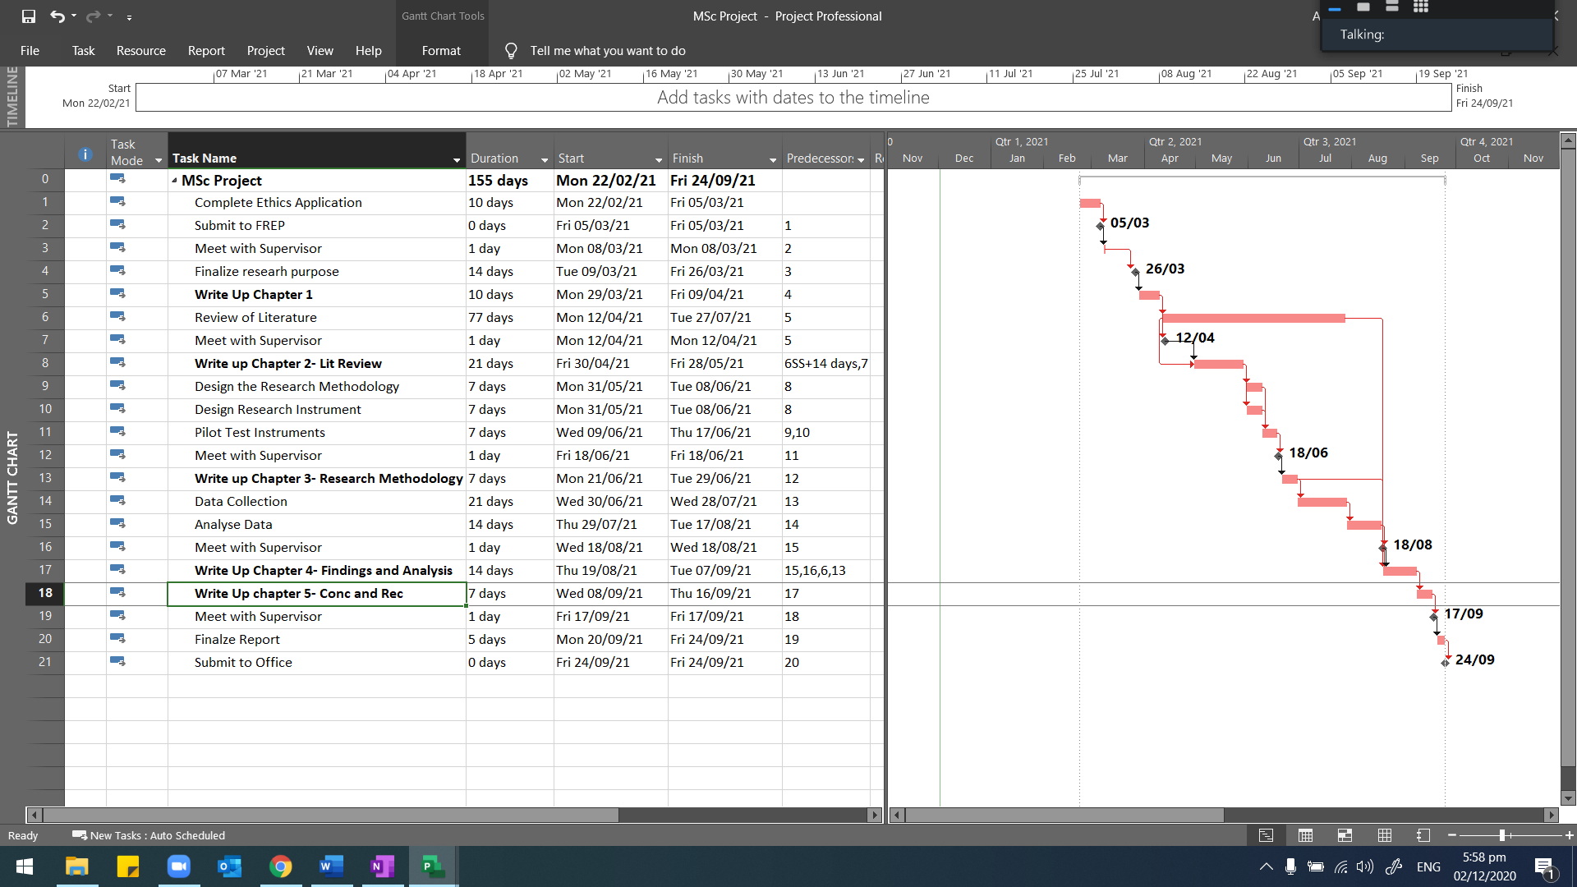

|  |  |
| --- | --- |
| Milestone | Planned Completion Date |
| Submit Ethics App | 5th March 2021 |
|  |  |
|  |  |
|  |  |
|  |  |
|  |  |
|  |  |

# 6. Ethics

Define ethics in research

State the risk category that your research falls into- YELLOW

See appendix for ethics checklist and Ethics Training Certificate

# 7. References

[Please delete the following text] Organise in alphabetical order by the last name of the author. Make sure that websites have a full reference, and not just the URL. Higher marks will be awarded for a reference section where the font and font style is consistent with the rest of the report, and does not differ in style or size. (See the library’s guidance on citation and referencing [<http://libweb.anglia.ac.uk/referencing/harvard.htm>]. Remember that citations are included within your text, and are usually the last name of the author and the year of publication, for example (Brown, 2011). References are the full information required to recall the resource, for example a website would have the following structure:

NHS Evidence, 2003. National Library of Guidelines. [online] Available at: <http://www.library.nhs.uk/guidelinesFinder> [Accessed 10 October 2009].

Appendix 1 Project Plan

SAMPLE-!!!

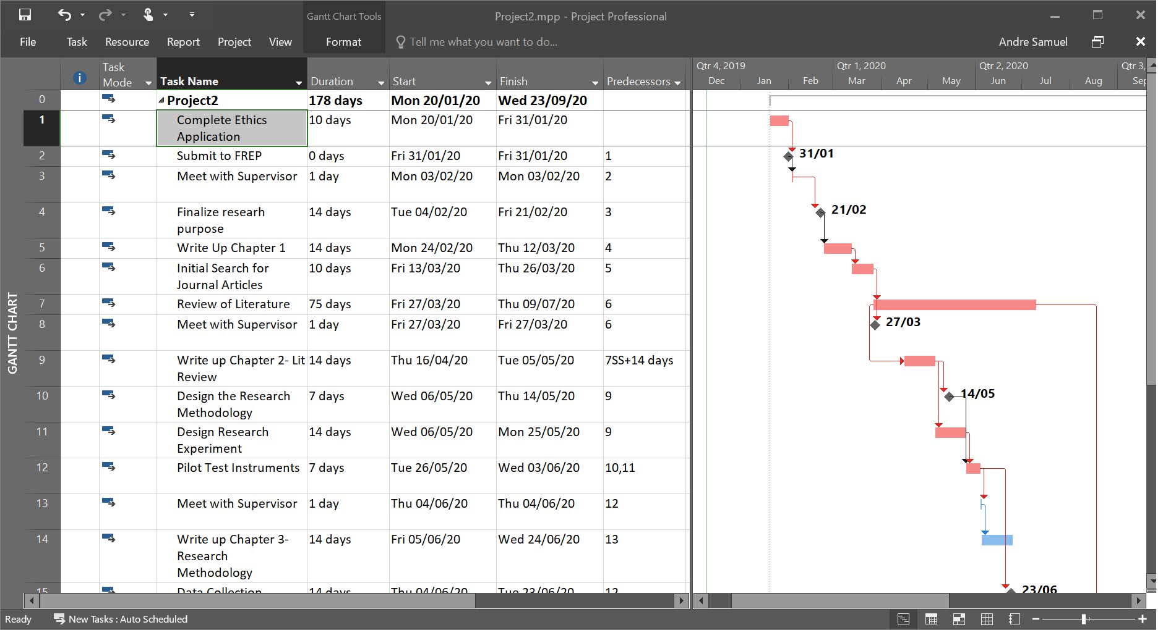

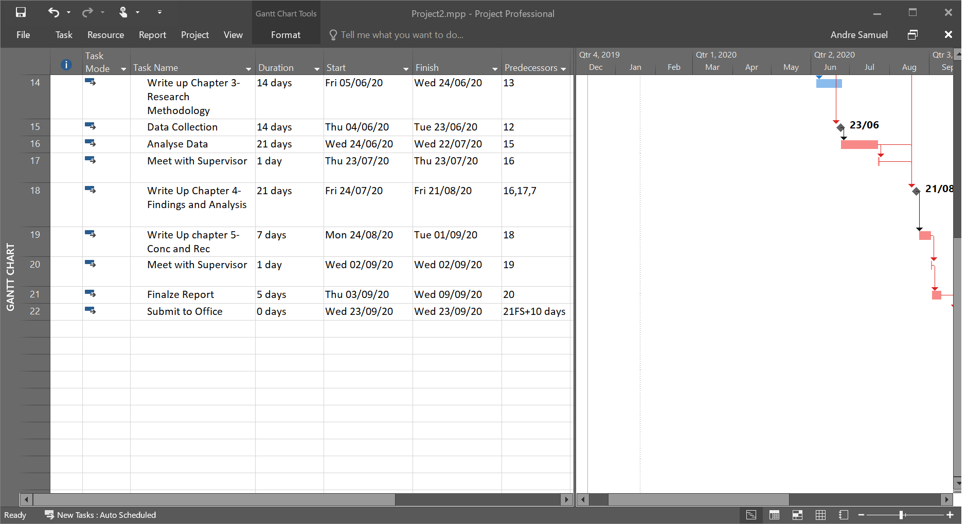

Appendix 2- Ethics Checklist and Certificate